Rasha Ragab Ibraheem 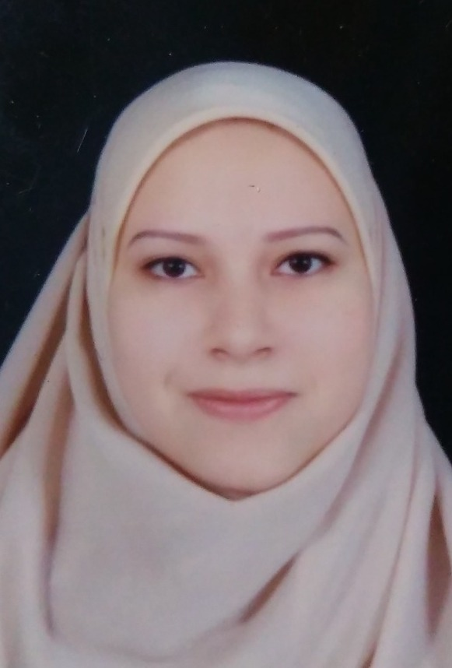
lecturer in Animal and poultry behaviour and management department,
Faculty of Veterinary Medicine
Phone: +2 01091804676
FAX: +2 082 2327982

E-mail: dr_rasha_vet85@yahoo.com
rasha.abdelhameed@vet.bsu.edu.eg
Scientific status:

-2007 B.Sc., Veterinary Medicine, Cairo University
-2012 Mv .Sc., Veterinary Medicine, (Animal and poultry behaviour and management) Beni-Seuf University
2018 ph D, Veterinary Medicine, (Animal and poultry behaviour and management) Beni-Seuf University

Functional status:
- Demonstrator, Department of Hygiene, Management and Zoonoses, Faculty of Veterinary Medicine Beni Suef University.
- Assistant Lecturer, Department of Hygiene, Management and Zoonoses, Faculty of Veterinary Medicine Beni Suef University.
- Lecturer, Department of Hygiene, Management and Zoonoses, Faculty of Veterinary Medicine Beni Suef University.

University Teaching Experience:
- practical teaching for students of Veterinary Medicine Undergraduate.
- E-learning of Animal Behaviour and Management in related to National E-learning Center, Ministery of Higher Education –Egypt.
- Teaching lecturers for undergraduate and post graduate students in the faculty of veterinary medicine.

Research:

In animal Behaviour and Management
- Ibrahim, R.R., Khalil, F., Mostafa, A.S., Emeash, H.H. Effects of probiotic on comfort and body care behaviors of broilers reared at different stocking densities Journal of Advanced Veterinary Research. 2018, 8(3), pp. 60–65.
- Ibrahim, R.R., Khalil, F., Mostafa, A.S., Emeash, H.H. Efficacy of probiotic in improving welfare and mitigating overcrowding stress in broilers Journal of Advanced Veterinary Research. 2018, 8(4), pp. 73–78.
- Khalil, F., Ibrahim, R.R., Emeash, H.H., Hassan, A.H.A. Probiotic supplementation alleviated stress and improved performance, meat quality, sensory acceptability and microbiological status of broilers. Journal of Advanced Veterinary Research. 2021, 11(2), pp. 93–101.
- Shehata, N., Ibrahim, R.R., Nady, S., Emeash, H.H., Khalil, F. Efficiency Of Thyme-Celery Mixture (TCM) In Reducing Physiological Stress Of Pregnant Ewes Under Two Different Housing Systems. Journal of Advanced Veterinary Research. 2023, 13(1), pp. 83–87.
- Saeed, H.E., Ibrahim, R.R., Kamel, S., El-Nahass, E.-S., Khalifa, A.G. Behavioral, biochemical, histopathological evaluation and gene expression of brain injury induced by nanoceria injected intranasal or intraperitoneal in mice. Toxicology ResearchThis link is disabled., 2024, 13(4), tfae095.
- Ibrahim, R.R., Hassan, A.H.A., Emeash, H.H., Khalil, F. Influence of Moringa Oleifera leaf extract and synbiotic supplementation on mitigating stress of broilers subjected to high stocking density. Journal of Advanced Veterinary ResearchThis link is disabled., 2024, 14(4), pp. 696–703.
- Ibrahim, R.R., Abdel Azeem, N.M., Emeash, H., Abdelghany, A.K. Performance, behavior, and welfare of turkey poults reared under different housing conditions. Journal of Advanced Veterinary ResearchThis link is disabled., 2024, 14(1), pp. 30–36

السيرة الذاتية ياللغة العربية:

ط ب/ رشا رجب إبراهيم
مدرس بقسم الرعاية وتنمية الثروة الحيوانية و الداجنه
كلية الطب البيطرى جامعة بنى سويف
تلبفاكس: 2327982 082 2+
تلبفون: +2 01091804676
بريد الكتروني: dr_rasha_vet85@yahoo.com
rasha.abdelhameed@vet.bsu.edu.eg
المؤهلات الدراسية:
1- بكالوريوس الطب البيطري جامعة القاهرة عام 2007
2- ماجيستير في العلوم الطبية البيطرية جامعة بنى سويف عام 2012
3- دكتوراة في العلوم الطبية البيطرية جامعة بنى سويف عام 2018
الاهتمام العلمي:
دراسة سلوكيات حيوانات المزرعة والدواجن ونظم الرعاية المتبعة وتأثيرها على كفاءة وسلوك الحيوان
االتدريس
سلوكيات الحيوان والدواجن ورعايتها

